

Output block test plan

Propulsion system simulation

Fangzhou chen Jiacong li Marco Hoogesteger Martijn Crombeen

*Organisation: Solar Boat Sealander*

*Client: Mr. R. Eijlers*

*Tutor: Mr. W. Haak*

*Date: 3-11-2020*

2020

Table of content

1. Aim & Hypothesis 2

1.1. Aim 2

1.2. Hypothesis 2

2. Variables 2

2.1. Inputs 2

2.2. Outputs 2

3. Tools 3

4. Method 3

4.1 Steps 3

5. Expect result 4

6. Conclusion 4

# Aim & Hypothesis

## Aim

The aim is to verify the outputs from the calculations components can be shown correctly by the output block.

## Hypothesis

The results shown by the output block are same as calculation results.

# Variables

These are the constants and variables that will be used during the test.

|  |  |
| --- | --- |
| Constants simulation | Keep constant at... |
| Battery level computer | Constant power source. |
| All input variables | Real positive numbers & ISO-notation. |

## Inputs

The limits stated are the limits of the real world. If values out of this range are entered, the outputs will be unreliable.

|  |  |
| --- | --- |
| Inputs | Value |
| Value 1 (input power) | Random positive numeric numbers |
| Value 2 (efficiency) | Random positive numeric numbers between 0 and 1 |

## Outputs

These are the outputs that will be monitored and will be used to see variations or changes in the system.

|  |  |
| --- | --- |
| Outputs | Value |
| Output value 1 (output power) | Random positive numeric numbers |
| Output value 2 (power loss) |

# Tools

|  |  |
| --- | --- |
| Testing tools | Demand |
| Computer | Windows 10 compatible |
| Excel | Newest version |
| Keyboard | No limit |
| Mouse | No limit |
| Calculator | Basic calculator |
| Pen & Paper | Basic pen & paper |

# Method

This section consists of actions that need to be performed during the test to conclude a result. The conditions of the constants stated in chapter “2. Variables” have to be met before executing the simulation. To execute the simulation, follow the steps stated in “4.1. Steps”.

In this test, the output value will be shown with a pie chart which consists of output power and power loss.

## 4.1 Steps

1. Create a new form in Excel.
2. Take the grid A2 as the input block of **value 1 (input power)**. Take the grid B2 as the input **value 2 (efficiency).**
3. Take the grid C2 as the indicator of **output value 1 (output power)**. Take the grid D2 as the indicator of **output value 2 (power loss)**. And add a formula to C2: = A2 * B2. Add a formula to D2: =A2 * (1 – B2).

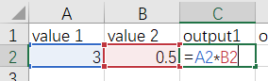

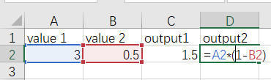

1. Choose a numeric value of **value 1 (input power)** and input this value to A2
2. Choose a numeric value between 0 and 1 of **value 2 (efficiency)** and input this value to B2
3. Calculate **output value 1 (output power)** and **output value 2 (power loss)** on paper.
4. Use the data from C2 and D2 to create a pie chart.

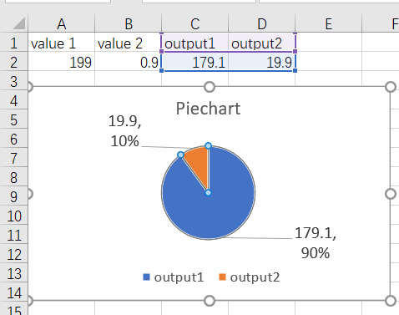

1. Compare the results from paper calculation and C2, D2 and pie chart.

# Expect result

The values of C2 and D2 are equal to results of paper calculation.

The ratio between C2 and D2 is equal to the value of efficiency.

The ratio of areas of **output value 1 (output power)** and **output value 2 (power loss)** in the pie chart is equal to the value of effiency.

The values of **output value 1 (output power)** and **output value 2 (power loss)** shown in pie chart are equal to values from C2 and D2.

# Conclusion

If every condition in ‘5. Expect result’ is met, the test is successful.

If one of the conditions in’5. Expect result’ can’t be met, the test is failed.